**Motherboard:**  [**Asus ROG STRIX X670E-A GAMING WIFI ATX AM5**](https://rog.asus.com/br/motherboards/rog-strix/rog-strix-x670e-a-gaming-wifi-model/)

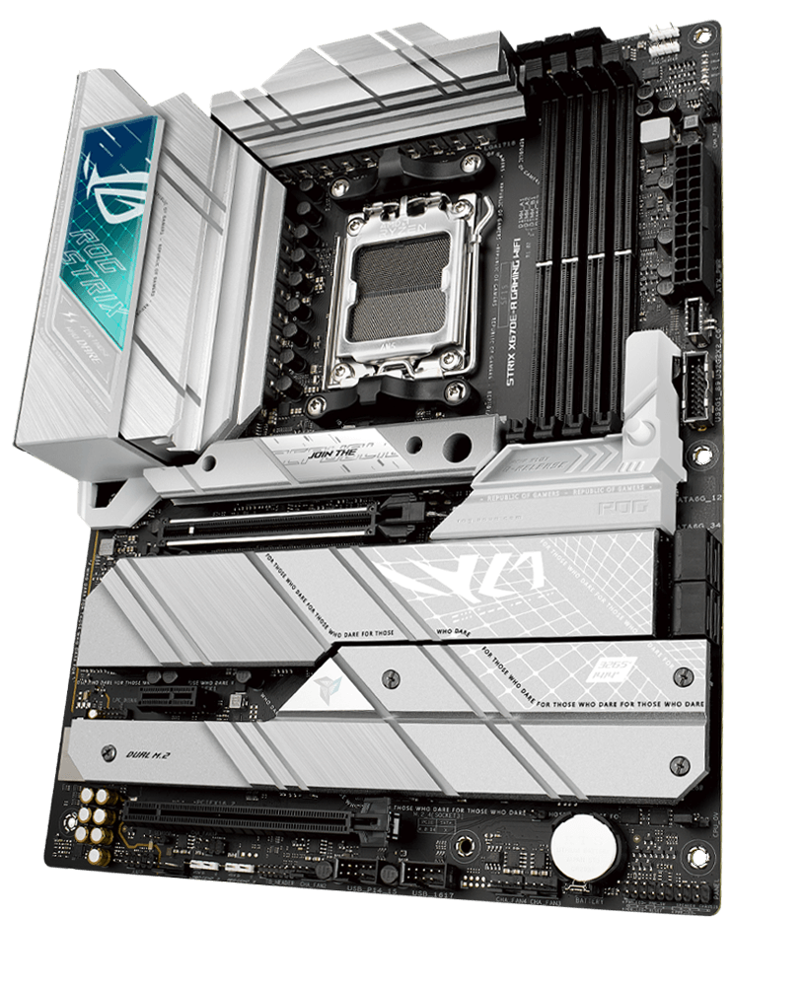

**Processador:**

[**Processador para desktop AMD Ryzen™ 7 9800X3D**](https://www.amd.com/pt/products/processors/desktops/ryzen/9000-series/amd-ryzen-7-9800x3d.html)

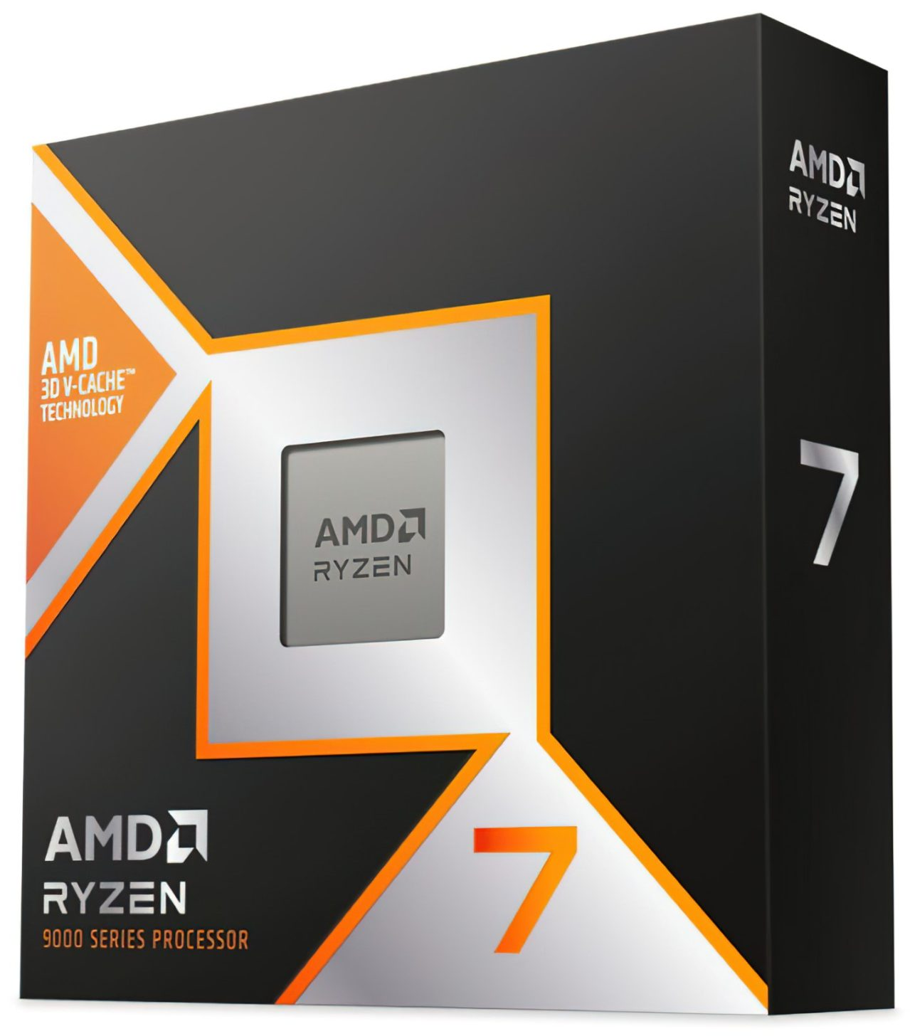

**Placa de vídeo:**

[**ROG Strix GeForce RTX 4090 24GB GDDR6X White OC Edition**](https://rog.asus.com/br/graphics-cards/graphics-cards/rog-strix/rog-strix-rtx4090-o24g-white-model/)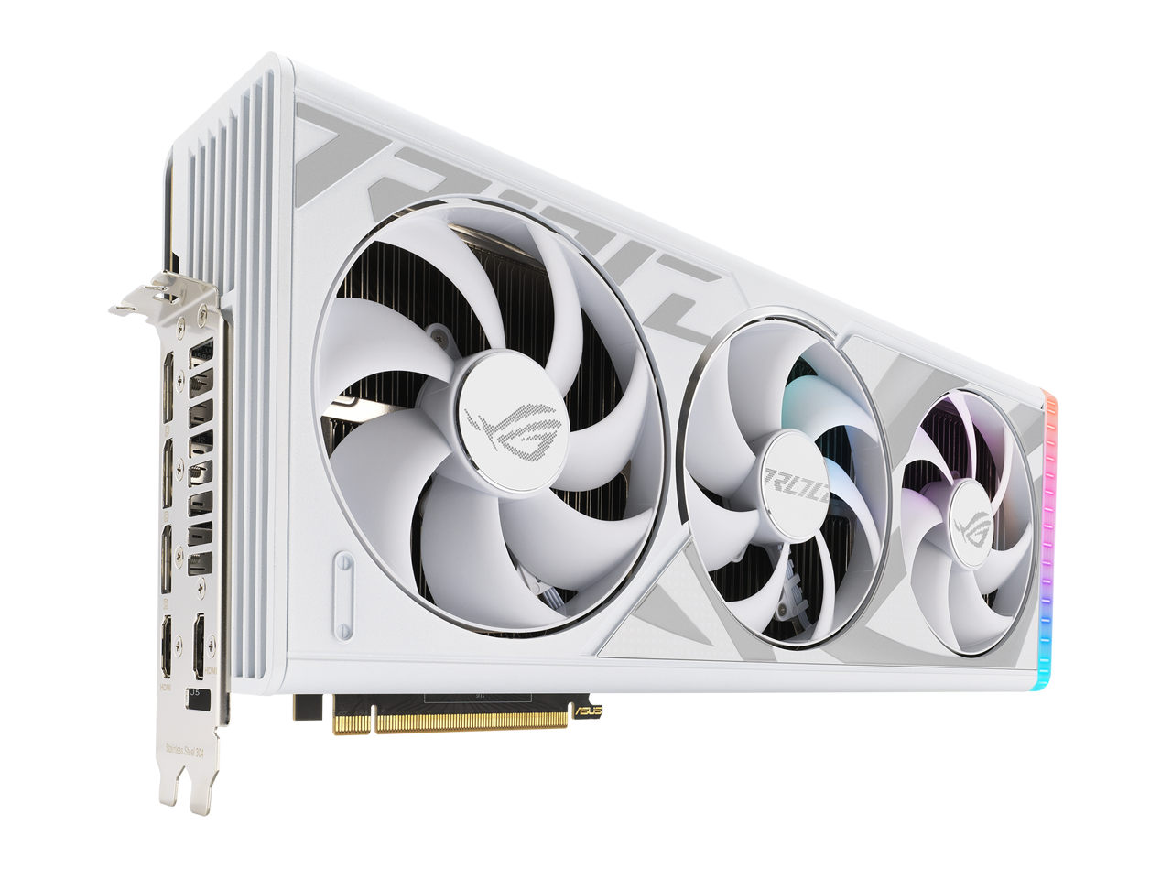

**Cooler:**

[**ROG Strix LC II 360 ARGB White Edition**](https://rog.asus.com/br/cooling/cpu-liquid-coolers/rog-strix-lc/rog-strix-lc-ii-360-argb-white-edition-model/)

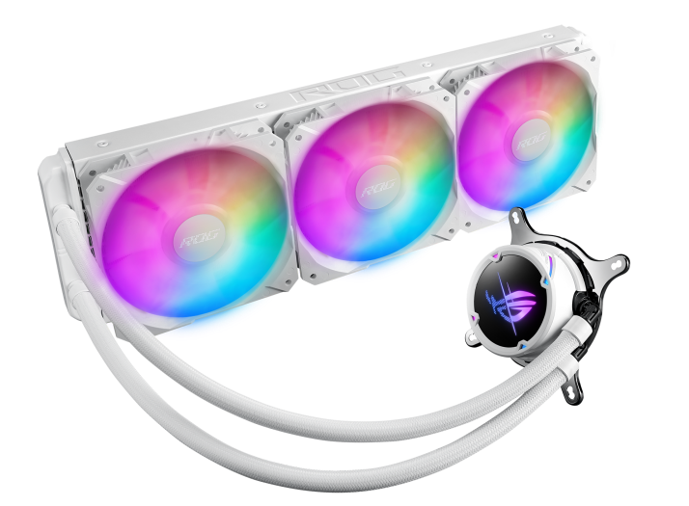

**RAM:**

**2x (**[**Kingston Fury Beast 32GB 6000Mhz**](https://www.kingstonstore.com.br/products/kf560c30bwe-32)**)**

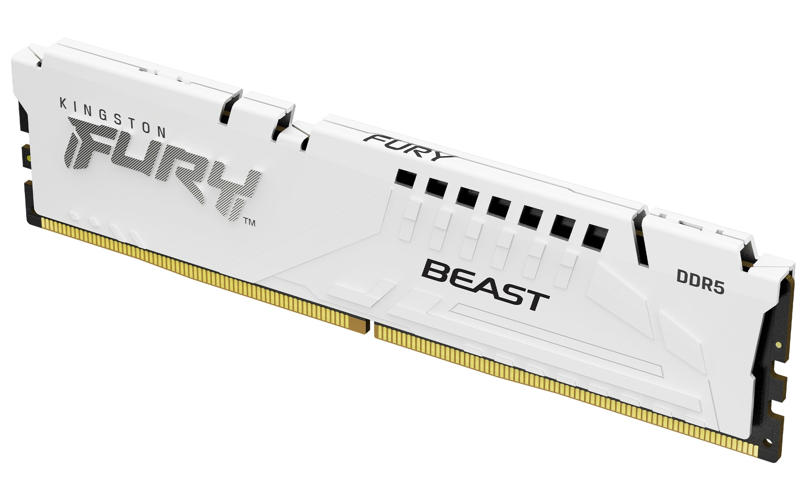

**Armazenamento:**

**3x (**[**Kingston SSD NV3 1TB M.2**](https://www.kingstonstore.com.br/products/snv3s-1000g)**)**

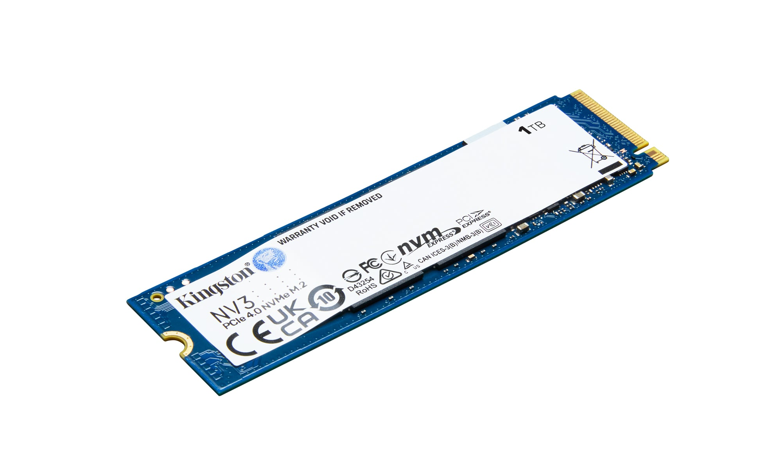

**Gabinete:**

[**Rise Mode Galaxy Glass Standard V2**](https://risemode.com/galaxy-glass-standard-v2-white/)

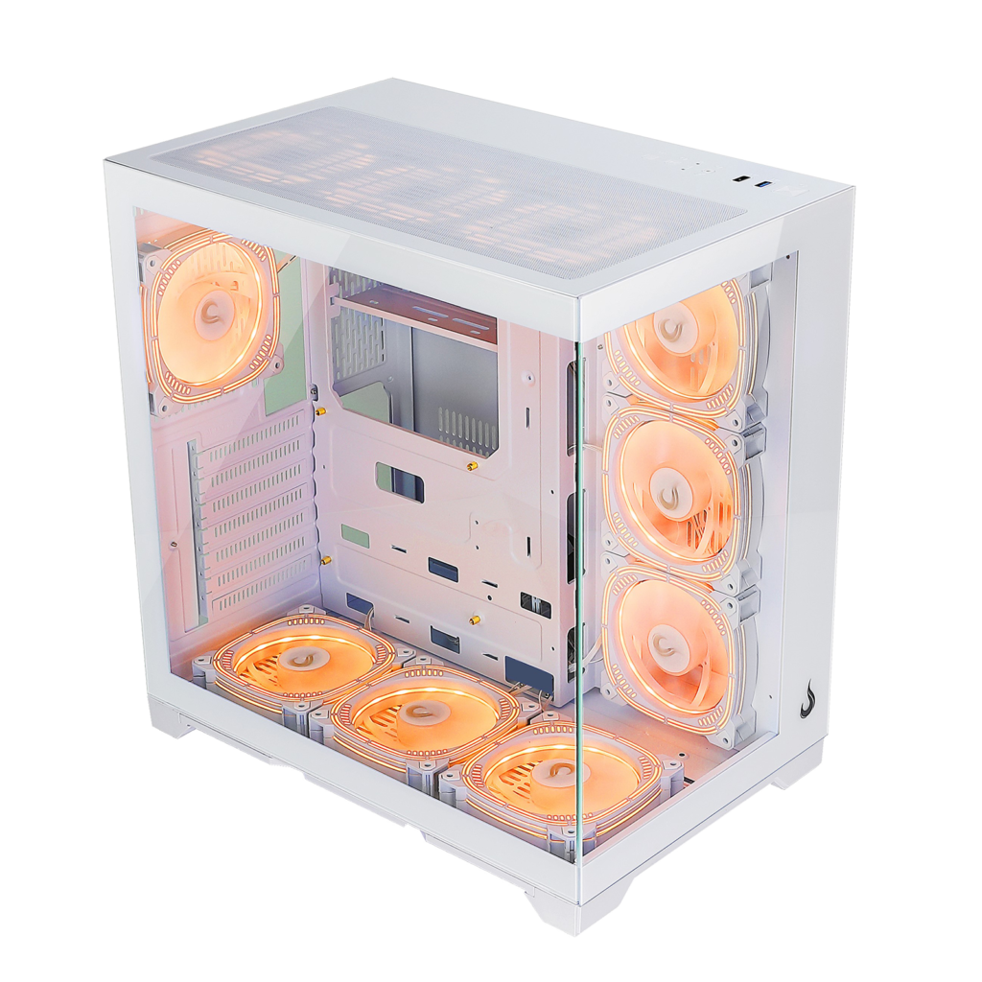

**PSU:**

[**Asus ROG Strix 1000G 1000W White Full-Modular ATX**](https://rog.asus.com/br/power-supply-units/rog-strix/rog-strix-1000g-model/)

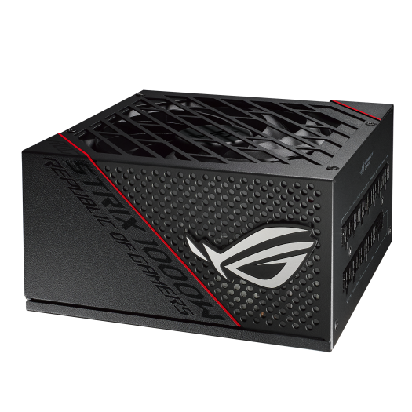

**Notebook:**

[**Asus ROG Strix G16 G614**](https://rog.asus.com/br/laptops/rog-strix/rog-strix-g16-2024/spec/) **Specs: Intel Core i9 14900HX, 32GB RAM, RTX 4080 12GB, SSD 2000GB**

